Приложение

Границы публичного сервитута
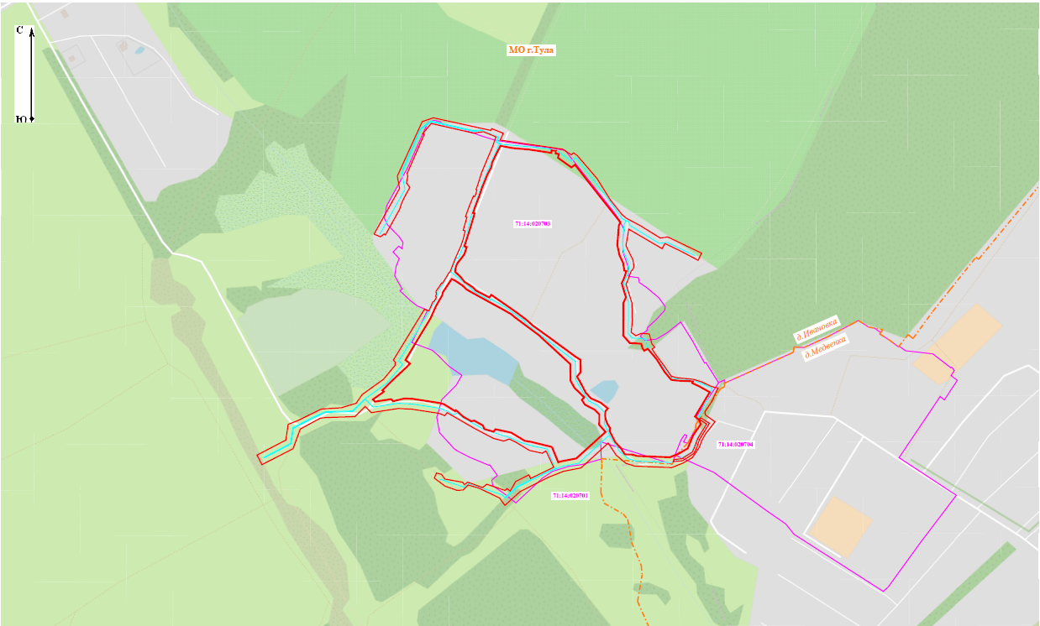
Масштаб 1:5000
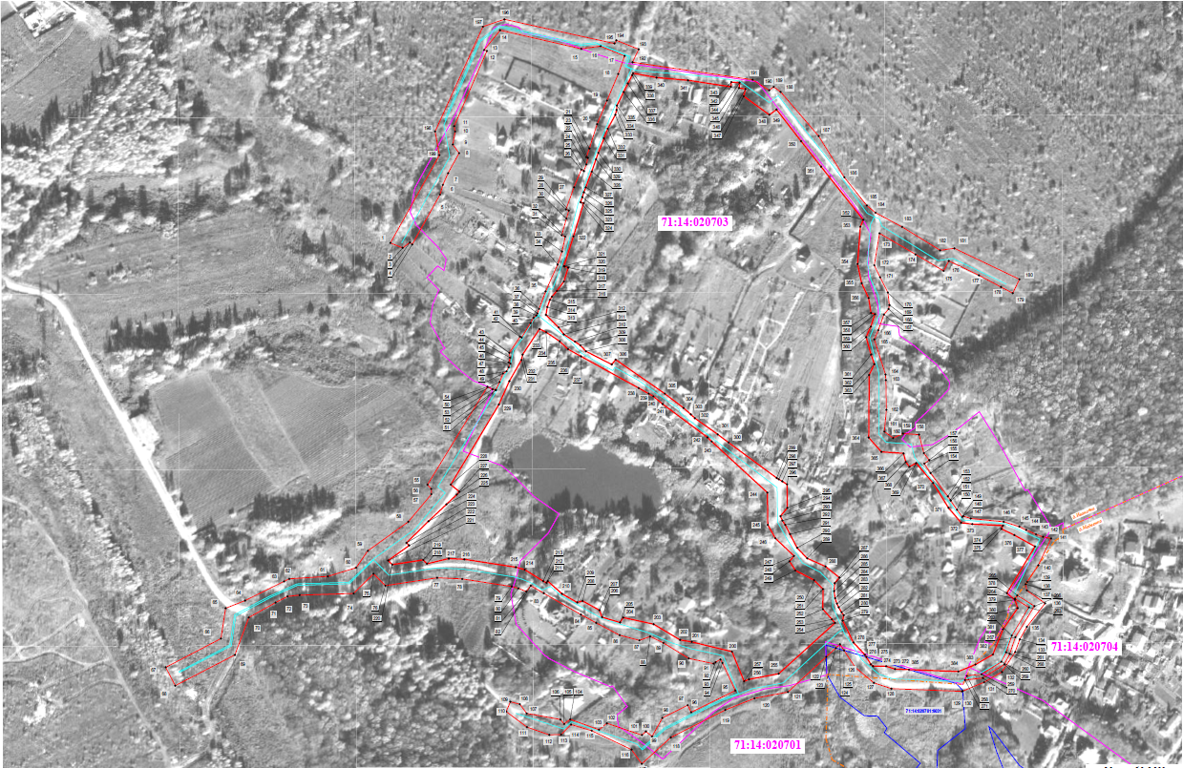
Масштаб 1:2100

Ведомость координат поворотных точек

площадь 54021 кв.м
Обозначение характерных точек границ | Координаты, м
Обозначение характерных точек границ | X | Y
1 | 752526.29 | 264502.88
2 | 752521.24 | 264515.27
3 | 752526.76 | 264522.62
4 | 752524.77 | 264524.92
5 | 752575.32 | 264553.05
6 | 752585.16 | 264555.91
7 | 752597.01 | 264561.22
8 | 752617.39 | 264572.40
9 | 752626.14 | 264565.94
10 | 752639.28 | 264568.42
11 | 752644.78 | 264567.39
12 | 752721.07 | 264600.55
13 | 752722.06 | 264597.68
14 | 752741.99 | 264613.87
15 | 752723.16 | 264696.05
16 | 752725.92 | 264715.59
17 | 752715.96 | 264739.89
18 | 752697.63 | 264733.44
19 | 752670.68 | 264722.13
20 | 752646.73 | 264712.04
21 | 752622.02 | 264704.23
22 | 752613.21 | 264701.11
23 | 752612.53 | 264702.72
24 | 752605.86 | 264701.21
25 | 752599.28 | 264698.64
26 | 752600.64 | 264696.11
27 | 752582.71 | 264688.69
28 | 752560.30 | 264680.54
29 | 752559.09 | 264683.45
30 | 752550.95 | 264681.01
31 | 752534.03 | 264676.25
32 | 752532.71 | 264679.87
33 | 752517.58 | 264676.59
34 | 752504.37 | 264672.10
35 | 752477.16 | 264659.96
36 | 752459.33 | 264653.28
37 | 752454.79 | 264651.63
38 | 752452.76 | 264650.58
39 | 752450.33 | 264647.78
40 | 752444.86 | 264644.77
41 | 752430.25 | 264635.70
42 | 752431.11 | 264634.14
43 | 752414.77 | 264623.14
44 | 752409.83 | 264623.99
45 | 752405.00 | 264622.68
46 | 752403.84 | 264624.31
47 | 752400.13 | 264622.52
48 | 752396.11 | 264620.35
49 | 752393.85 | 264616.86
50 | 752385.22 | 264613.37
51 | 752376.98 | 264609.63
52 | 752376.96 | 264609.42
53 | 752377.85 | 264606.30
54 | 752380.29 | 264601.03
55 | 752280.97 | 264540.40
56 | 752276.69 | 264544.17
57 | 752271.33 | 264544.27
58 | 752243.37 | 264520.96
59 | 752213.92 | 264480.01
60 | 752196.78 | 264468.15
61 | 752188.01 | 264439.50
62 | 752185.53 | 264400.48
63 | 752182.91 | 264395.14
64 | 752163.47 | 264355.78
65 | 752155.65 | 264336.00
66 | 752124.89 | 264331.26
67 | 752095.73 | 264275.43
68 | 752077.10 | 264285.01
69 | 752108.31 | 264345.41
70 | 752146.27 | 264359.58
71 | 752161.39 | 264386.60
72 | 752167.72 | 264398.72
73 | 752168.94 | 264410.92
74 | 752170.62 | 264465.65
75 | 752190.65 | 264485.73
76 | 752178.61 | 264497.77
77 | 752186.59 | 264550.22
78 | 752185.38 | 264575.57
79 | 752177.70 | 264625.68
80 | 752175.88 | 264632.39
81 | 752172.61 | 264640.43
82 | 752178.58 | 264644.97
83 | 752170.94 | 264658.04
84 | 752149.20 | 264695.68
85 | 752140.89 | 264711.09
86 | 752128.36 | 264734.87
87 | 752123.14 | 264754.94
88 | 752127.00 | 264765.75
89 | 752120.53 | 264779.17
90 | 752104.82 | 264804.83
91 | 752099.44 | 264830.01
92 | 752100.91 | 264831.89
93 | 752103.76 | 264836.90
94 | 752100.16 | 264838.95
95 | 752072.12 | 264851.99
96 | 752050.23 | 264807.26
97 | 752057.33 | 264803.76
98 | 752044.34 | 264778.11
99 | 752025.64 | 264767.68
100 | 752030.65 | 264761.41
101 | 752027.02 | 264757.42
102 | 752038.98 | 264721.92
103 | 752032.42 | 264713.91
104 | 752043.00 | 264684.83
105 | 752038.17 | 264678.75
106 | 752042.78 | 264674.98
107 | 752048.92 | 264640.88
108 | 752058.29 | 264633.81
109 | 752060.77 | 264624.26
110 | 752050.82 | 264620.05
111 | 752035.12 | 264641.07
112 | 752027.23 | 264663.62
113 | 752027.54 | 264675.69
114 | 752037.62 | 264685.74
115 | 752031.45 | 264706.64
116 | 752012.24 | 264746.93
117 | 751997.81 | 264757.30
118 | 752024.55 | 264786.61
119 | 752052.52 | 264841.82
120 | 752064.24 | 264871.40
121 | 752070.67 | 264905.20
122 | 752106.38 | 264943.99
123 | 752115.30 | 264953.71
124 | 752119.17 | 264957.87
125 | 752112.84 | 264962.03
126 | 752095.70 | 264973.30
127 | 752079.95 | 264992.18
128 | 752074.08 | 265009.99
129 | 752071.32 | 265081.32
130 | 752071.66 | 265082.14
131 | 752080.58 | 265103.87
132 | 752090.97 | 265121.84
133 | 752111.30 | 265135.25
134 | 752124.17 | 265139.96
135 | 752136.84 | 265147.15
136 | 752160.71 | 265165.55
137 | 752173.78 | 265147.08
138 | 752180.05 | 265145.80
139 | 752182.37 | 265147.36
140 | 752199.26 | 265158.72
141 | 752226.49 | 265171.56
142 | 752228.07 | 265163.42
143 | 752230.69 | 265156.23
144 | 752235.12 | 265146.50
145 | 752238.52 | 265139.49
146 | 752243.38 | 265123.58
147 | 752246.76 | 265090.29
148 | 752249.06 | 265082.73
149 | 752248.25 | 265081.62
150 | 752255.55 | 265076.35
151 | 752264.75 | 265070.06
152 | 752265.58 | 265069.68
153 | 752269.19 | 265067.06
154 | 752292.83 | 265049.64
155 | 752302.42 | 265043.23
156 | 752305.94 | 265048.23
157 | 752312.98 | 265042.85
158 | 752331.78 | 265038.00
159 | 752332.87 | 265021.76
160 | 752328.34 | 265011.75
161 | 752334.89 | 265002.87
162 | 752356.97 | 265004.88
163 | 752387.11 | 265004.32
164 | 752392.76 | 265004.04
165 | 752428.46 | 264992.71
166 | 752437.71 | 264996.71
167 | 752453.64 | 265002.41
168 | 752459.22 | 265007.10
169 | 752463.27 | 265007.89
170 | 752475.95 | 265006.37
171 | 752491.39 | 264998.56
172 | 752503.56 | 264992.65
173 | 752536.02 | 264997.96
174 | 752514.75 | 265034.37
175 | 752497.90 | 265062.86
176 | 752508.02 | 265068.09
177 | 752493.45 | 265098.48
178 | 752481.58 | 265120.89
179 | 752475.34 | 265132.84
180 | 752489.33 | 265139.54
181 | 752520.82 | 265073.72
182 | 752518.76 | 265059.37
183 | 752542.53 | 265020.79
184 | 752556.96 | 264993.87
185 | 752564.23 | 264985.10
186 | 752592.87 | 264962.35
187 | 752634.64 | 264936.35
188 | 752679.56 | 264897.83
189 | 752684.58 | 264890.77
190 | 752681.15 | 264886.24
191 | 752691.79 | 264869.46
192 | 752709.59 | 264747.92
193 | 752722.77 | 264754.16
194 | 752731.82 | 264731.51
195 | 752728.53 | 264729.74
196 | 752753.12 | 264618.25
197 | 752745.70 | 264596.52
198 | 752639.34 | 264548.08
199 | 752615.36 | 264552.44
1 | 752526.29 | 264502.88
200 | 752111.62 | 264848.64
201 | 752121.54 | 264807.93
202 | 752123.55 | 264796.03
203 | 752139.54 | 264769.27
204 | 752146.23 | 264738.58
205 | 752141.22 | 264735.28
206 | 752146.57 | 264717.13
207 | 752153.64 | 264714.43
208 | 752163.06 | 264697.35
209 | 752161.57 | 264691.99
210 | 752170.26 | 264676.55
211 | 752183.17 | 264662.13
212 | 752181.40 | 264660.77
213 | 752183.21 | 264657.44
214 | 752194.86 | 264638.79
215 | 752197.29 | 264629.83
216 | 752205.30 | 264577.57
217 | 752206.05 | 264561.92
218 | 752200.81 | 264539.82
219 | 752204.67 | 264536.05
220 | 752199.91 | 264504.76
221 | 752204.08 | 264500.58
222 | 752219.31 | 264521.77
223 | 752222.02 | 264519.13
224 | 752243.87 | 264541.39
225 | 752261.06 | 264559.54
226 | 752270.94 | 264569.98
227 | 752274.01 | 264572.54
228 | 752281.10 | 264563.90
229 | 752362.37 | 264612.69
230 | 752386.09 | 264623.23
231 | 752407.58 | 264635.47
232 | 752413.00 | 264636.65
233 | 752438.98 | 264653.75
234 | 752435.68 | 264660.55
235 | 752426.51 | 264674.20
236 | 752418.56 | 264682.61
237 | 752411.19 | 264695.71
238 | 752379.00 | 264754.17
239 | 752373.33 | 264764.23
240 | 752370.68 | 264768.95
241 | 752362.87 | 264778.40
242 | 752328.96 | 264823.81
243 | 752324.84 | 264828.05
244 | 752273.02 | 264884.41
245 | 752240.30 | 264884.85
246 | 752226.68 | 264892.48
247 | 752208.67 | 264911.38
248 | 752203.28 | 264906.83
249 | 752194.04 | 264912.75
250 | 752184.16 | 264931.73
251 | 752175.10 | 264940.70
252 | 752154.76 | 264940.62
253 | 752144.45 | 264949.67
254 | 752140.79 | 264952.87
255 | 752089.25 | 264895.86
256 | 752083.53 | 264865.80
257 | 752081.58 | 264860.85
200 | 752111.62 | 264848.64
258 | 752087.06 | 265086.39
259 | 752088.70 | 265101.18
260 | 752101.42 | 265121.26
261 | 752110.89 | 265126.06
262 | 752127.96 | 265131.81
263 | 752156.52 | 265149.21
264 | 752165.33 | 265135.00
265 | 752168.57 | 265137.38
266 | 752157.84 | 265154.70
267 | 752126.30 | 265135.47
268 | 752109.21 | 265129.69
269 | 752098.63 | 265124.33
270 | 752084.83 | 265102.54
271 | 752082.82 | 265084.49
258 | 752087.06 | 265086.39
272 | 752093.96 | 265013.57
273 | 752096.90 | 265004.62
274 | 752096.92 | 264991.26
275 | 752098.80 | 264989.17
276 | 752106.16 | 264984.63
277 | 752108.42 | 264983.23
278 | 752120.98 | 264971.56
279 | 752143.06 | 264960.59
280 | 752148.50 | 264961.66
281 | 752151.59 | 264959.50
282 | 752156.57 | 264956.58
283 | 752160.32 | 264954.87
284 | 752165.85 | 264953.01
285 | 752173.03 | 264951.98
286 | 752181.15 | 264952.63
287 | 752186.81 | 264957.25
288 | 752198.00 | 264943.26
289 | 752206.29 | 264924.69
290 | 752217.06 | 264914.51
291 | 752230.75 | 264907.40
292 | 752240.28 | 264902.52
293 | 752244.58 | 264899.66
294 | 752249.04 | 264897.67
295 | 752257.50 | 264904.62
296 | 752281.37 | 264904.30
297 | 752284.41 | 264899.42
298 | 752286.52 | 264896.02
299 | 752287.87 | 264893.86
300 | 752323.85 | 264845.03
301 | 752332.06 | 264834.13
302 | 752348.50 | 264811.08
303 | 752352.39 | 264806.98
304 | 752358.85 | 264799.54
305 | 752373.35 | 264780.56
306 | 752407.88 | 264730.86
307 | 752403.00 | 264726.86
308 | 752416.36 | 264700.76
309 | 752422.34 | 264695.15
310 | 752426.13 | 264689.66
311 | 752433.49 | 264678.40
312 | 752440.52 | 264673.13
313 | 752453.32 | 264660.31
314 | 752461.22 | 264661.63
315 | 752468.67 | 264664.37
316 | 752471.79 | 264666.37
317 | 752477.63 | 264671.32
318 | 752487.16 | 264678.44
319 | 752501.14 | 264682.84
320 | 752502.39 | 264679.04
321 | 752502.66 | 264678.47
322 | 752532.95 | 264688.13
323 | 752566.71 | 264698.41
324 | 752567.58 | 264695.27
325 | 752572.68 | 264697.10
326 | 752577.71 | 264698.59
327 | 752582.66 | 264700.56
328 | 752598.66 | 264706.65
329 | 752611.11 | 264711.00
330 | 752617.74 | 264713.25
331 | 752632.41 | 264719.05
332 | 752642.09 | 264722.88
333 | 752656.28 | 264730.54
334 | 752661.32 | 264731.81
335 | 752665.70 | 264732.15
336 | 752679.47 | 264738.97
337 | 752688.02 | 264743.24
338 | 752696.57 | 264747.60
339 | 752698.47 | 264748.54
340 | 752693.98 | 264772.29
341 | 752691.26 | 264804.02
342 | 752684.67 | 264847.56
343 | 752689.45 | 264847.88
344 | 752688.74 | 264856.24
345 | 752683.44 | 264855.79
346 | 752682.51 | 264862.30
347 | 752675.17 | 264860.42
348 | 752656.27 | 264886.48
349 | 752661.68 | 264893.64
350 | 752629.44 | 264918.55
351 | 752603.57 | 264938.83
352 | 752549.68 | 264981.54
353 | 752542.79 | 264978.55
354 | 752504.93 | 264975.70
355 | 752485.29 | 264979.92
356 | 752470.39 | 264986.90
357 | 752455.33 | 264989.37
358 | 752454.00 | 264993.28
359 | 752441.42 | 264989.17
360 | 752430.67 | 264984.37
361 | 752413.07 | 264989.34
362 | 752403.28 | 264992.70
363 | 752392.36 | 264987.43
364 | 752328.79 | 264987.01
365 | 752314.30 | 264999.81
366 | 752312.79 | 265022.24
367 | 752304.06 | 265024.50
368 | 752299.22 | 265028.19
369 | 752302.93 | 265034.94
370 | 752282.72 | 265052.14
371 | 752257.61 | 265067.77
372 | 752242.42 | 265080.55
373 | 752241.04 | 265091.81
374 | 752239.48 | 265122.86
375 | 752236.18 | 265121.34
376 | 752229.91 | 265134.45
377 | 752218.35 | 265155.32
378 | 752170.92 | 265126.87
379 | 752164.21 | 265134.98
380 | 752155.83 | 265137.82
381 | 752134.33 | 265122.91
382 | 752108.79 | 265112.71
383 | 752098.57 | 265095.03
384 | 752091.47 | 265077.74
385 | 752093.41 | 265027.73
272 | 752093.96 | 265013.57

Используемые условные знаки и обозначения:
 | - проектные границы публичного сервитута
00:00:000000:000 | - граница и номер земельного участка
00:00:000000 | - граница и номер кадастрового деления территории
 | - граница административного-территориального деления
 | - проектное местоположение инженерного сооружения
 | - характерная точка границы публичного сервитута

